6A^{th} Grade: Unit 12, Lesson 1
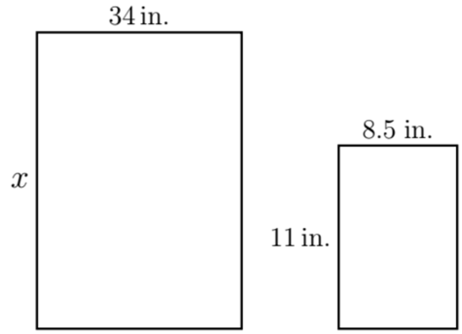
- Magazines are put together on large canvases which are then reduced, proportionally, to smaller magazine pages so people can easily read them. The diagram shows the large canvas and the standard magazine with dimensions in inches (in.). If a standard magazine page is 8.5 in. in width and 11 in. in length and the large canvas has a width of 34 in., write a proportion to solve for the length of the canvas.

$$\frac{8.5}{11}=\frac{34}{x}$$
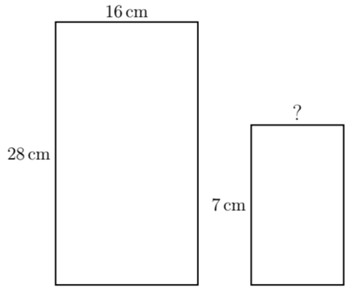
- Two rectangles are shown with measurements in centimeters (cm). If the rectangles are proportional, what is the width of the second rectangle?

4 cm
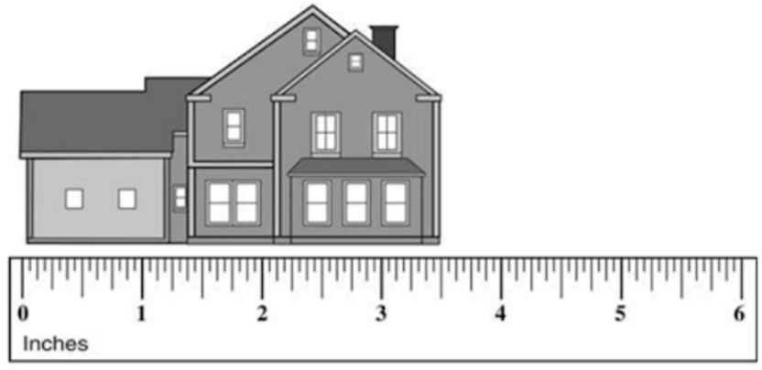

- A scale drawing of a house is shown with a ruler, in inches (in.). The scale for the drawing above is 0.75 in. = 12 feet (ft). Write a proportion that can be used to determine the actual length of the house.

$$\frac{x}{3.5}=\frac{0.75}{12}$$

